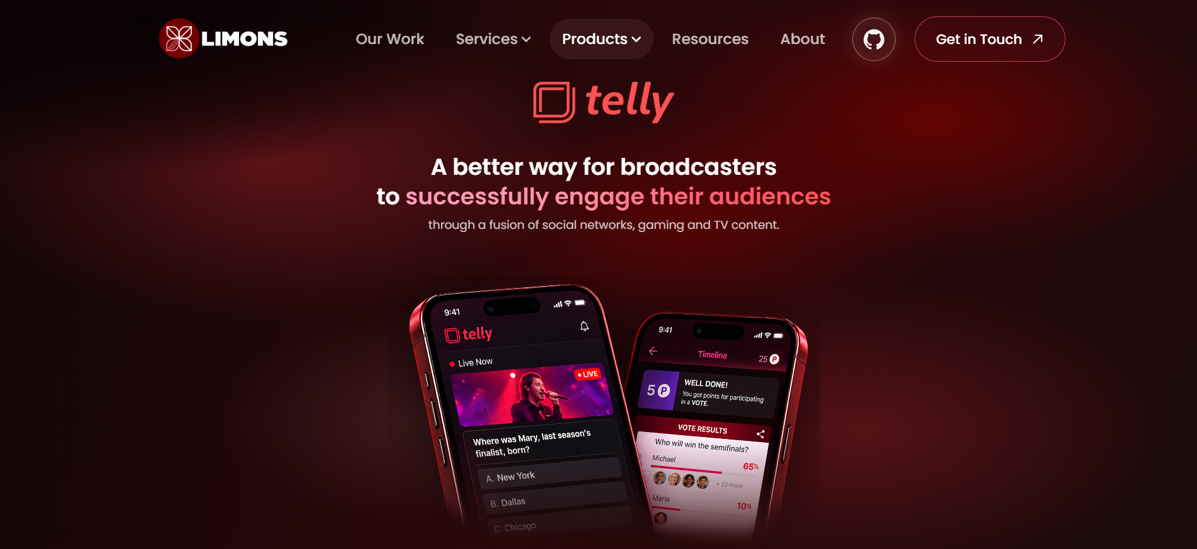

Feels there is a box behind img.. Pls remove or fix

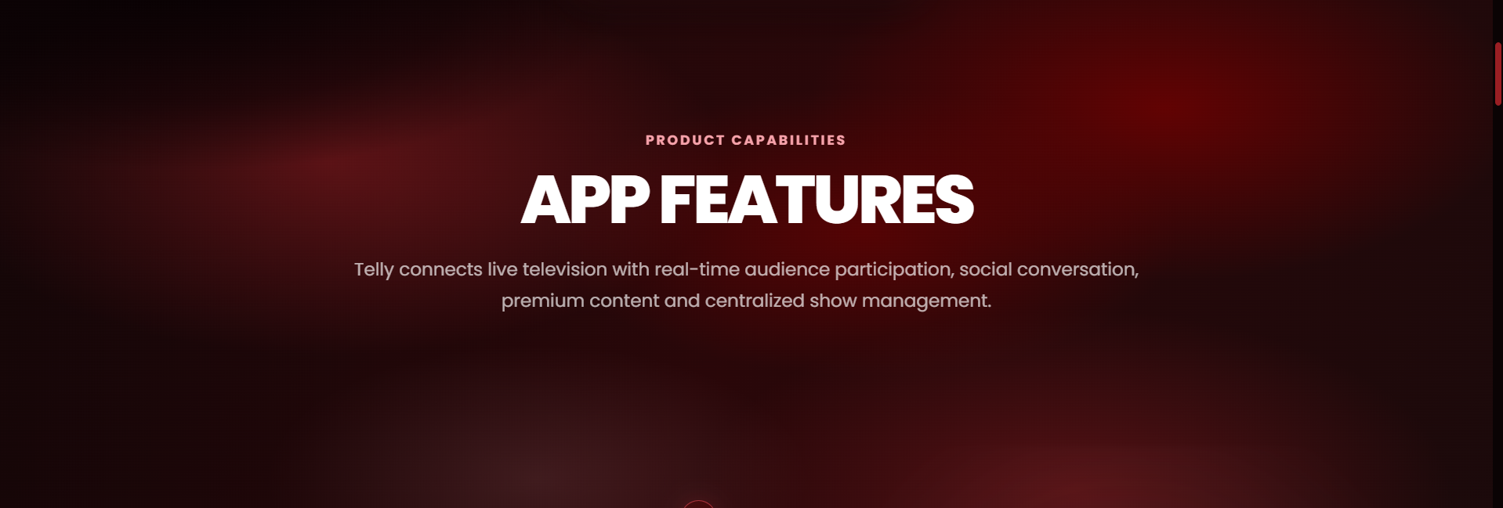

Pls remove the title “app features” and product capabilities subtitle from here.

The description should behave like this:
https://drive.google.com/file/d/1mPaNGdPXdPIOprjN6Q2iVISylrCl_HhJ/view?usp=sharing

So that the size is much bigger and have this animation. This animation can be made by saying: “Pls add animation where text is grey by default and with scroll, the words/letters become white”

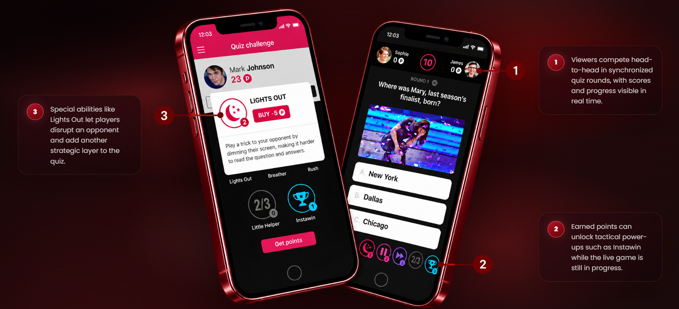

Remove the numbering from the explanation boxes and try to keep each box very close to the number in image. (throughout the page)

Also, pls add very cool modern hover effects (See from dribbble.com)... the current one looks too AI.
Also the overall animations of the website feels too AI. So pls add cool, modern and premium animations (Claude makes good animations usually)
The header has too abrupt and jerky animations… (and almost the same throughout the website) so pls add transitions n animations which look cool and smooth.

Also add, floating animations to all mockups. (The home page mockup has a bittt dramatic animation but it will be simple continuous floating animation on other pages)

